English Assignment
Report Writing
SHORTAGE IN MUNCIPAL WATER SUPPLY

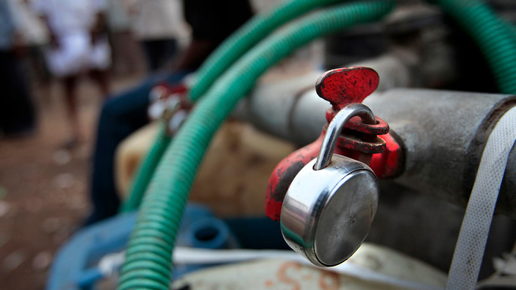

Submitted By
Kshitj Kadane

Roll Number
821269
Acknowledgments:

Firstly I would like to thank my uncle and aunt who live in Raichand Niwas for introducing me to all the residents of that building and the owner of that building.
Secondly I would like to acknowledge the helpful nature of all the residents of Raichand Niwas with regard to my research in the water shortage prevailing there.
I would also like to thank the nearby shop owners and businessmen who have revealed the corrupt activities of the municipality officials.

Abstract:

In this research assignment, I have highlighted the water shortage faced by the people living in downtown Mumbai's one of the most populated as well as prestigious area, Dadar. It covers the topics such as the reasons for water shortage, how the residents have found ways to tackle it, and how the Municipal corporation has responded to their pleas.

Introduction:

Dadar is the largest town in south Mumbai, both by area and population. Dadar is situated at the the heart of Mumbai and is of valuable significance to Mumbai, both politically and spiritually. Siddhivinayaka temple, the most popular temple in Maharashtra is located in Dadar.

Chawl is a 2-4 storey building, most prominently seen in Mumbai, which are constructed similar to a normal building but have a large number of small area rooms of about 100sq.feet each. A typical house in a Chawl has an area of 180-200 sq. feet. Such structures are common in Mumbai owing to the sky high land cost. The average number of people living in a flat in a Chawl are usually high and are more than 5.

Raichand Niwas is a Chawl in Dadar, right next to the prestigious Siddhivinayaka temple. It has exactly 100 flats, is a 3 storey building and approximately 350 people live in this building. It was constructed in 1907 and has been renovated almost every ten years, 2011 being the latest. It is declared as a safe structure by the Brihanmumbai Municipal Corporation(BMC).

Scope:

Although water shortage is common place in India, I would like to focus my topic to Mumbai, specifically a building in Mumbai which is the birthplace of my father, and where my grandparents live.

Significance:

I consider that my topic of report is significant because water shortage is a thing faced by almost every district and by all classes of people in India. This is something, against which each individual and the Government must work together to diminish its deadly effects.

Report:

Introduction

Water is one of the most basic necessities of human beings. An average human is considered to utilize 125 liters of water in a urban household, however in India, the water consumption is considerably below these universal standards. In Mumbai, the BMC water supply takes place in the following manner:

- Drinking water is released for a one hour duration at moderate pressure.
- Water for regular use is released roughly for one and a half hour duration at high pressure in the evening.

Such water supply is divided into zones and each zone has its own time period of supply. In Raichand Niwas, drinking water is supplied at 5 A.M and the evening supply takes place at around 4 to 5.30 PM.

Being an old building, it does not have a common water tank on the terrace or anywhere in the building. Each household has their own water tank of 250 or 500 liters capacity which is filled by the evening supply daily. The BMC promises uninterrupted water supply daily at the given time with a constant pressure, but this generally doesn't happen. The water pressure is always low and is not sufficient to fill the water tank of each and every household everyday, neither is the water supply available for a duration of 90 minutes. It is mostly cut out within an hour. This is not only the problem of Raichand Niwas, but is present in almost each and every old-structure in downtown Mumbai.

Residents' Point of View

Sunanda Kadane has been living in a flat on ground floor for the past 52 years. According to her, the water supply had been regular till the year 1990. Since then, irregularities have developed in the BMC water supply system and timings. Conditions have been worsened since 2005. It used to take approximately half an hour to fifteen minutes to completely fill the tank of 250L, but now-a-days, it takes about one hour. Also to aggravate the discomfort, BMC occasionally skips water supplies for an entire day. According to the residents, they get a supply for about 6 to 5 days a week. Supply is at a high pressure only for about three to four days.

At the same time, adjacent to Raichand Niwas is Kamna Co.op Housing Society which has two high rise buildings. Each of the high rise buildings have a large water tank located at the ninth floor. These buildings use electric pumps to pull water from the supplies. Also, the water supply shortage is present only for single buildings and not for large housing societies.

The water pressure is even lower on the topmost third floor. The water pipeline going to the third floor requires a pump to pull the water up as the pressure is only sufficient till the second floor. During festive seasons however, the BMC has guaranteed regular and continuous water supply, but then the residents have just one question, “If it's possible to supply continuously for such occasions, why not make it permanent?”

“What generally happens during the shortage is that all the households are not able to fill up their tanks completely or even partially.” says Mr. Shrikant Jadhav, who is a resident for the past 40 years. “we end up filling only half of our tanks, which is not sufficient for an entire day” he says.

Adaptations

They have adapted to various techniques like filling a drum of water when there is a proper supply of water. During the low pressure supply, what the residents do is that they fill water sequentially, one after another as the flow is not sufficient to fill all simultaneously. During the summer months of May and June, Mumbai faces upto 50% water shortages due to the receding water levels of Upper Vaitarna, Modak Sagar and Bhatsa lakes. In the months of May and June, water tankers of 5000L capacity are ordered by the building committee and water is supplied, thus increasing the expenses.

Official Response

Upon inquiring about their complains to the ministry, the residents unanimously say that that is the last option one must consider. Mr. Jacob Pinto lives on the third floor and he is a government servant. He has visited the BMC office multiple times, but in vain. The officials keep giving senseless replies. According to the businessmen who own shops on the ground floor, the officials do not look into the matter because of corruption, but this a common excuse say the officials and that the work is under process.

In an emotional tone, Mrs. Bhagyashree Patil, 72 says “I've been living in this building since my birth. Back then Mumbai was a jungle, but somehow life was good. I've seen all these towers come up (mentioning the high rise buildings) in front of me. We just don't like the idea of unequal distribution...that's it.” Whilst on the contrary, the youth living there have a surprisingly different approach, they say that as a true Mumbaikar, they have somehow adjusted with the problems they are facing.

Raichand Niwas is just a mere example of what is a much bigger problem, water shortage. South Mumbai, being a million-plus city, at least has sufficiently developed water supply systems, but there are many other districts and villages which are facing such problems. In the end, it's all in our hands how we utilize water.

Methodology:

I have myself stayed at Raichand Niwas for over two months during which I could feel the water shortage problems myself. In order to fill in this report, I have combined my past experiences and also interviewed many residents during the Dussehra holidays this year. Raichand Niwas can be reached via Dadar station. It's located in Prabhadevi and is right next to the famous temple as mentioned earlier. The names of the BMC officials are not revealed, however the residents were happy to share their names.

Conclusion:
I would like to conclude this report by quoting few lines from the poem 'The Rime of the Ancient Mariner' by Samuel Taylor Coleridge,

“Water, water, every where,
And all the boards did shrink;
Water, water, every where,
Nor any drop to drink.”

-x-x-x-x-x-x-x-x-x-x-x-

